Web 1.0, Web 2.0, Web 3.0

Web 1.0 refers to the first stage in the World Web 1.0 refers to the first stage in the World Wide Web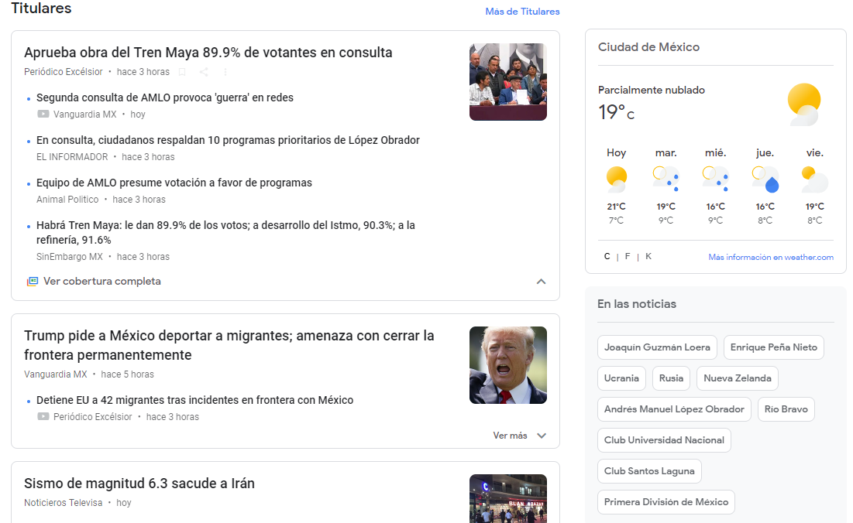 NEWS

Web 1.0 sites are static they contain useful information but there is no reason for the viewer to come back to the web site. An example of this can be a personal web page that contains information about the owner but never changes.
Web 2.0 is the current state of online technology as it compares to the early days of the Web
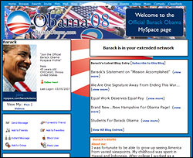
A Web 2.0 blog or MySpace page can be an example of, this type of “blogs” allow the owner of the account to frequently update information

Web 3.0
Wed 3.0 is an advancement of web 1.0 and 1.0 it includes these features
Artificial Intelligence
3D Graphics
Semantic Web (it improves web technologies in order to generate, share and connect content through search and analysis based on the ability to understand the meaning of words)
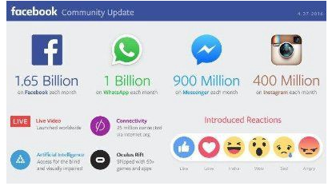

HOW STUFF WORKS “Web 1.0” https://computer.howstuffworks.com/web-101.htm0 (nov 26 2018)
WhatIs “Web 2.0" https://whatis.techtarget.com/definition/Web-20-or-Web-2

https://www.techopedia.com/definition/27960/web-10

https://www.expertsystem.com/web-3-0/

https://makeawebsitehub.com/examples-of-blogs/

https://news.google.com/?hl=es-419&gl=MX&ceid=MX:es-419

https://hackernoon.com/the-web-3-0-the-web-transition-is-coming-892108fd0d

